Top 10 Logics
public class Basic_10_Logics {
public static void main(String [] args) {
int fact=1;
for(int i=1;i<=5;i++) {
fact=fact*i;
}
System.out.println(fact);
//-----------------------------------------//
int first=0,second=1,next;
for(int i=0;i<6;i++) {
System.out.println(first);
next=first+second;
first=second;
second=next;
}
//-----------------------------------------//
int i = 1, no = 9;
for (i = 2; i < no; i++) {
if (no % i == 0) {
System.out.println("Not prime");
break;
}
}
if (i == no) {
System.out.println("Prime Number");
}
//-----------------------------------------//
}
}

Thread Creation

Public class MyThread extends Thread {
@Override
public void run() {
System.out.println("Thread running using Thread class");
}
public static void main(String[] args) {
MyThread t1 = new MyThread();
t1.start(); // Start thread
}
}
public class MyRunnable implements Runnable {
@Override
public void run() {
System.out.println("Thread running using Runnable interface");
}
public static void main(String[] args) {
Thread t1 = new Thread(new MyRunnable());
t1.start(); // Start thread
}
}

Custom exception

class InvalidAgeException extends Exception {
public InvalidAgeException(String message) {
super(message);
}
}

public class TestCustomException {
public static void checkAge(int age) throws InvalidAgeException {
if (age < 18) {
throw new InvalidAgeException("Age below 18 is not allowed!");
} else {
System.out.println("Eligible!");
}
}

public static void main(String[] args) {
try {
checkAge(15); // invalid age
}
catch (InvalidAgeException e) {
System.out.println("Exception occurred: " + e.getMessage());
}
}
}

Collection hierarchy

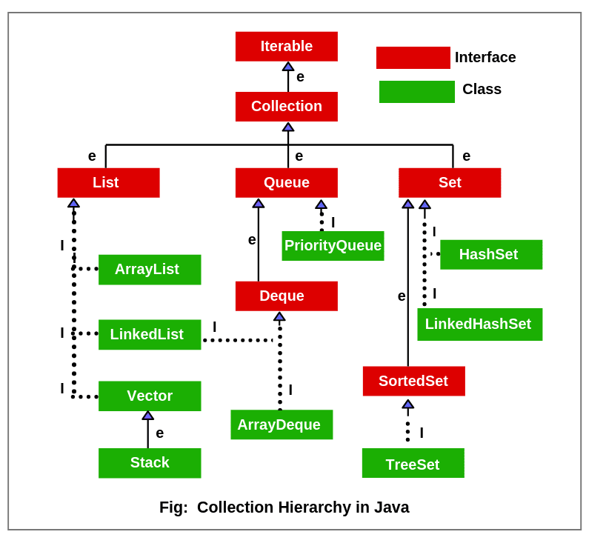
Map

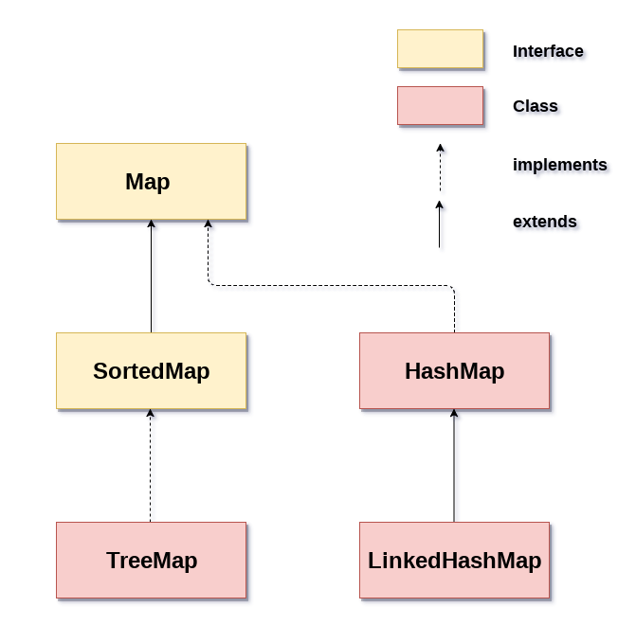

File Reading and writing

class ReadFileExample {
public static void main(String[] args) throws Exception {
FileReader fr = new FileReader("sample.txt");
BufferedReader br = new BufferedReader(fr);

String line;
while ((line = br.readLine()) != null) {
System.out.println(line);
}

br.close();
fr.close();
}
}

class WriteFileExample {
public static void main(String[] args) throws Exception {
FileWriter fw = new FileWriter("sample.txt");
BufferedWriter bw = new BufferedWriter(fw);

bw.write("Hello, this is first line!");
bw.newLine();
bw.write("This is second line!");

bw.close();
fw.close();

System.out.println("File written successfully!");
}
}

WebDriver Architecture

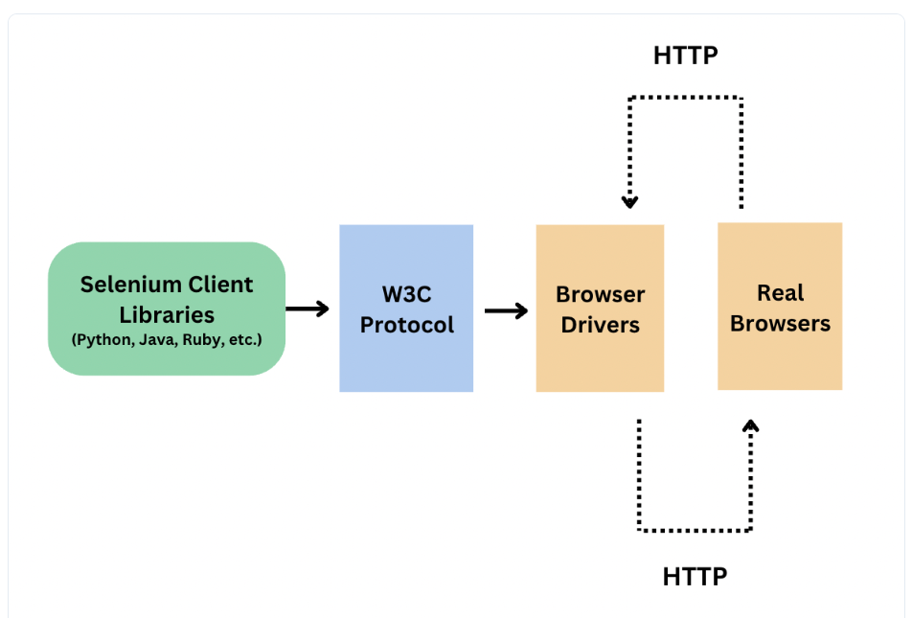

Selenium 4 Features

1) W3C WebDriver Standard
- Selenium 4 fully follows W3C protocol.
- More stable communication with browsers.
- No JSON Wire protocol translation layer.
- Better compatibility with Chrome, Firefox, Edge.

2) Relative Locators
- Locate elements based on position of other elements.
- Types:
above()
below()
toLeftOf()
toRightOf()
near()
Example:
with(By.tagName("button")).below(element);

3) New Window / New Tab
- Easily open new tab/window.
Example:
driver.switchTo().newWindow(WindowType.TAB);

4) Chrome DevTools Protocol (CDP) Support
- Allows interacting with browser internals
- Examples:
- Network logs
- Block URLs
- Mock geolocation
- Console logs
- Device emulation

5) Selenium Grid 4
- Complete redesign
- Easy to set up
- Standalone / Hub-Node / Distributed
- Supports Docker & Kubernetes
- Built-in Observability (tracing, logs, metrics)
- Supports GraphQL API

6) Selenium Manager (Auto driver download)
- Auto resolves driver binaries (Chrome, Edge, Firefox)
- No need WebDriverManager/com manually downloading drivers
Example:
WebDriver driver = new ChromeDriver();

7) Improved Actions API
- Enhanced keyboard, mouse, wheel control
Example:
new Actions(driver).scrollByAmount(0, 500).perform();

8) Full Page Screenshot & Element Screenshot
- Take screenshots of web element only
Example:
element.getScreenshotAs(OutputType.FILE);

9) Improved Window Management
- New methods:
minimize()
fullscreen()
setSize()
Example:
driver.manage().window().minimize();

10) Better Support for WebDriver BiDi
- Real-time events from browser
- Still improving

11) Updated PageFactory & Annotations
- Works with explicit waits
- Cleaner initialization

12) Options & Capabilities changes
- Use browser options instead of DesiredCapabilities
- Example:
ChromeOptions options = new ChromeOptions();

SELENIUM NAVIGATION COMMANDS

Navigation commands are used to move between pages (browser navigation).

1) navigate().to()
- Opens URL (similar to get())
Example:
driver.navigate().to("https://google.com");

2) navigate().back()
- Goes to previous page
Example:
driver.navigate().back();

3) navigate().forward()
- Goes to next page
Example:
driver.navigate().forward();

4) navigate().refresh()
- Reloads the current page
Example:
driver.navigate().refresh();

DIFFERENCE: get() vs navigate().to()

driver.get()
- Waits until page is fully loaded
- Mostly used for fresh URL launch

driver.navigate().to()
- Does not always wait for full load
- Mostly used for switching URLs

WINDOW HANDLING IN SELENIUM

Used when multiple browser windows or tabs are opened.

Main methods:
1) getWindowHandle()
- Returns current window ID (String)
Example:
String parentID = driver.getWindowHandle();

2) getWindowHandles()
- Returns Set of ALL window IDs
Example:
Set<String> allIDs = driver.getWindowHandles();

3) switchTo().window()
- Switch control to specific window using window ID
Example:
driver.switchTo().window(childID);

4) close()
- Closes current window
Example:
driver.close();

5) quit()
- Closes all browser windows
Example:
driver.quit();

STEP-BY-STEP EXAMPLE

public class SwitchWindowExample {
public static void main(String[] args) {
WebDriver driver = new ChromeDriver();

// Open the first URL
driver.get("https://example.com");

// Open a new window (simulate by clicking a link or using JavaScript)
((JavascriptExecutor) driver).executeScript("window.open('https://google.com','_blank');");

// Get window handles
Set<String> windowHandles = driver.getWindowHandles();
String originalWindow = driver.getWindowHandle();

// Switch to the new window
for (String handle : windowHandles) {
if (!handle.equals(originalWindow)) {
driver.switchTo().window(handle);
break;
}
}

// Now you're in the new window
System.out.println("Current URL: " + driver.getCurrentUrl());

// Switch back to the original window
driver.switchTo().window(originalWindow);
System.out.println("Back to original URL: " + driver.getCurrentUrl());

driver.quit();
}
}

ACTIONS CLASS IN SELENIUM

Used to handle:
• Mouse Actions
• Keyboard Actions
• Drag-and-Drop
• Double Click
• Right Click
• Hover
• Click & Hold
• Release
• Composite Actions

BASIC INITIALIZATION

Actions act = new Actions(driver);
1) Mouse Hover
act.moveToElement(element).perform();
2) Right Click (Context Click)
act.contextClick(element).perform();
3) Double Click
act.doubleClick(element).perform();
4) Drag and Drop
act.dragAndDrop(source, target).perform();
5) Click & Hold + Release
act.clickAndHold(source).moveToElement(target).release().perform();
6) Send Keys using Actions
act.sendKeys(element, "Hello").perform();
7) Scroll (Selenium 4)
act.scrollByAmount(0, 500).perform();
8) Move to Element & Click
act.moveToElement(element).click().perform();
9) Composite Actions Example
act.moveToElement(element)
.click()
.sendKeys("Hello")
.build()
.perform();

Excel Reading and writing (Apache POI)

class ExcelWrite {

public static void main(String[] args) throws Exception {
Workbook wb = new XSSFWorkbook();
Sheet sheet = wb.createSheet("Data");

Row row = sheet.createRow(0);
Cell cell = row.createCell(0);
cell.setCellValue("Hello Excel");

FileOutputStream fos = new FileOutputStream("data.xlsx");
wb.write(fos);

fos.close();
wb.close();
System.out.println("Excel Written Successfully!");
}
}

class ExcelRead {

public static void main(String[] args) throws Exception {
FileInputStream fis = new FileInputStream("data.xlsx");
Workbook wb = new XSSFWorkbook(fis);

Sheet sheet = wb.getSheet("Data");
Row row = sheet.getRow(0);
Cell cell = row.getCell(0);

System.out.println(cell.getStringCellValue());

wb.close();
fis.close();
}
}

Property File Reading

class ReadPropertyFile {

public static void main(String[] args) throws Exception {

FileInputStream fis = new FileInputStream("config.properties");

Properties prop = new Properties();
prop.load(fis);

System.out.println(prop.getProperty("username"));
System.out.println(prop.getProperty("password"));
System.out.println(prop.getProperty("url"));

fis.close();
}
}

Log4j

private static final Logger log = LogManager.getLogger(ClassName.class);

log.info("Info message");
log.error("Error message");
log.warn("Warn message");
log.debug("Debug message");

Auto It Code
; Wait for File Upload window
WinWaitActive("Open")

; Type file path
Send("C:\Users\Sample\Desktop\file.txt")

; Press ENTER
Send("{ENTER}")

Runtime.getRuntime().exec("path\\Upload.exe");

File Validation

String downloadFolder = "C:\\Users\\YourUser\\Downloads";
File folder = new File(downloadFolder);
File[] listOfFiles = folder.listFiles(); // returns an array of files

String expectedFile = "sample.txt";
boolean fileFound = false;

// Loop through the files
for (File file : listOfFiles) {
if (file.isFile() && file.getName().equals(expectedFile)) {
fileFound = true;
break;
}
}

if (fileFound) {
System.out.println("File downloaded successfully: " + expectedFile);
} else {
System.out.println("File not found: " + expectedFile);
}
}
}

Broken Links Logic

List<WebElement> links = driver.findElements(By.tagName("a"));
System.out.println("Total links found: " + links.size());
for (WebElement linkElement : links) {
String url = linkElement.getAttribute("href");

// Skip if href is null or empty
if (url == null || url.isEmpty()) {
System.out.println("Empty or null link skipped");
continue;
}
try {
URL link = new URL(url);
URLConnection urlConnection = link.openConnection();
HttpURLConnection connection = (HttpURLConnection) urlConnection;
connection.setRequestMethod("HEAD");
connection.connect();
int responseCode = connection.getResponseCode();
if (responseCode >= 400) {
System.out.println("Broken link: " + url + " --> " + responseCode);
} else {
System.out.println("Valid link: " + url + " --> " + responseCode);
}
} catch (Exception e) {
System.out.println("Exception for link: " + url + " --> " + e.getMessage());
}
}

SELENIUM WAITS – SYNTAXES

1) Implicit Wait
driver.manage().timeouts().implicitlyWait(10, TimeUnit.SECONDS);

(Selenium 4 – new syntax)
driver.manage().timeouts().implicitlyWait(Duration.ofSeconds(10));

2) Explicit Wait
WebDriverWait wait = new WebDriverWait(driver, Duration.ofSeconds(10));

wait.until(ExpectedConditions.visibilityOf(element));
wait.until(ExpectedConditions.elementToBeClickable(element));
wait.until(ExpectedConditions.presenceOfElementLocated(By.id("id")));
wait.until(ExpectedConditions.alertIsPresent());
wait.until(ExpectedConditions.textToBePresentInElement(element, "text"));
wait.until(ExpectedConditions.invisibilityOf(element));
wait.until(ExpectedConditions.frameToBeAvailableAndSwitchToIt("frameName"));

3) Fluent Wait
Wait<WebDriver> wait = new FluentWait<>(driver)
.withTimeout(Duration.ofSeconds(20))
.pollingEvery(Duration.ofSeconds(2))
.ignoring(Exception.class);
wait.until(ExpectedConditions.visibilityOf(element));

4) Thread Sleep
Thread.sleep(2000); // 2 seconds

Java script Executor
JavascriptExecutor js = (JavascriptExecutor) driver;

WebElement element = driver.findElement(By.id("myElement"));

1. JavaScript Click
js.executeScript("arguments[0].click();", element);

2. Move to element (scroll into view)
js.executeScript("arguments[0].scrollIntoView(true);", element);

3. Scroll page by pixels (down 500px)
js.executeScript("window.scrollBy(0,500);");

4. Send text to element
js.executeScript("arguments[0].value='Hello World';", element);

HANDLE AUTO-SUGGESTIONS IN SELENIUM

Steps:
1) Enter text in search box
2) Capture suggestion list
3) Loop through suggestions
4) Click matching one

BASIC CODE

WebElement search = driver.findElement(By.id("searchBox"));
search.sendKeys("Selenium");

List<WebElement> list = driver.findElements(By.xpath("//ul/li")); // update locator as needed

for(WebElement option : list) {
if(option.getText().equalsIgnoreCase("selenium webdriver")) {
option.click();
break;
}
}

OR USING CONTAINS

for(WebElement option : list) {
if(option.getText().contains("webdriver")) {
option.click();
break;
}
}

HANDLING HIDDEN ELEMENTS IN SELENIUM

public class HiddenElementHandler {
public static void main(String[] args) {
WebDriver driver = new ChromeDriver();
driver.get("https://example.com");

// Locate hidden element
WebElement hiddenElement = driver.findElement(By.id("hiddenInput"));

// Use JavaScript to set value or click
JavascriptExecutor js = (JavascriptExecutor) driver;
js.executeScript("arguments[0].value='test value';", hiddenElement);
js.executeScript("arguments[0].click();", hiddenElement);

driver.quit();
}
}

ROBOT CLASS – SIMPLE CODE

class RobotExample {
public static void main(String[] args) throws Exception {

Robot r = new Robot();
r.keyPress(KeyEvent.VK_ENTER);
r.keyRelease(KeyEvent.VK_ENTER);

// Press TAB
r.keyPress(KeyEvent.VK_TAB);
r.keyRelease(KeyEvent.VK_TAB);
}
}

Failure test cases execution in TestNG
import org.testng.IRetryAnalyzer;
import org.testng.ITestResult;

public class RetryAnalyzer implements IRetryAnalyzer {
private int attempt = 0;
private final int maxRetry = 2; // retry 2 times

@Override
public boolean retry(ITestResult result) {
if (attempt < maxRetry) {
attempt++;
return true;
}
return false;
}
}

public class RetryListener implements IAnnotationTransformer {
@Override
public void transform(ITestAnnotation ann, Class testClass,
Constructor testConstructor, Method testMethod) {
if (ann.getRetryAnalyzer() == null) {
ann.setRetryAnalyzer(RetryAnalyzer.class);
}
}
}

<!DOCTYPE suite SYSTEM "https://testng.org/testng-1.0.dtd">
<suite name="Suite">
<listeners>
<listener class-name="your.package.RetryListener"/>
</listeners>

<test name="AllTests">
<packages>
<package name="your.tests.package"/>
</packages>
</test>
</suite>

TestNg Reports

<!-- TestNG -->
<dependency>
<groupId>org.testng</groupId>
<artifactId>testng</artifactId>
<version>7.10.2</version>
<scope>test</scope>
</dependency>

<!-- ExtentReports -->
<dependency>
<groupId>com.aventstack</groupId>
<artifactId>extentreports</artifactId>
<version>5.1.1</version>
</dependency>

public final class ExtentManager {
private static ExtentReports extent;
private ExtentManager() {}
public static ExtentReports getInstance() {
if (extent == null) {
String path = System.getProperty("user.dir") + "/reports/extent-report.html";
ExtentSparkReporter spark = new ExtentSparkReporter(path);
spark.config().setReportName("Automation Test Report");
spark.config().setDocumentTitle("Test Execution");

extent = new ExtentReports();
extent.attachReporter(spark);
extent.setSystemInfo("Project", "Demo");
extent.setSystemInfo("Env", "QA");
}
return extent;
}
}

public class ReportListener implements ITestListener, ISuiteListener {
private static ExtentReports extent;
private static final ThreadLocal<ExtentTest> test = new ThreadLocal<>();

@Override
public void onStart(ISuite suite) {
extent = ExtentManager.getInstance();
}

@Override
public void onFinish(ISuite suite) {
if (extent != null) extent.flush();
}

@Override
public void onTestStart(ITestResult result) {
ExtentTest t = extent.createTest(result.getMethod().getMethodName());
test.set(t);
}

@Override
public void onTestSuccess(ITestResult result) {
test.get().log(Status.PASS, "Passed");
}

@Override
public void onTestFailure(ITestResult result) {
test.get().log(Status.FAIL, result.getThrowable());
}

@Override
public void onTestSkipped(ITestResult result) {
test.get().log(Status.SKIP, "Skipped");
}
}

public class SampleTest {

@Test
public void passTest() {
Assert.assertTrue(true);
}

@Test
public void failTest() {
Assert.fail("Failing intentionally to demo report");
}

@Test
public void skipTest() {
throw new SkipException("Skipping intentionally");
}
}

TESTNG PARAMETERS EXAMPLE

testng.xml
----------
<!DOCTYPE suite SYSTEM "https://testng.org/testng-1.0.dtd">
<suite name="Suite">
<test name="Test Parameters">
<parameter name="username" value="admin"/>
<parameter name="password" value="admin123"/>
<classes>
<class name="test.ParameterTest"/>
</classes>
</test>
</suite>
public class ParameterTest {

@Test
@Parameters({"username", "password"})
public void login(String user, String pass) {
System.out.println("Username: " + user);
System.out.println("Password: " + pass);
}
}

OUTPUT
Username: admin
Password: admin123

TESTNG GROUPS EXAMPLE

public class GroupTest {

@Test(groups = {"smoke"})
public void test1() {
System.out.println("Smoke Test");
}

@Test(groups = {"regression"})
public void test2() {
System.out.println("Regression Test");
}

@Test(groups = {"smoke", "regression"})
public void test3() {
System.out.println("Smoke + Regression Test");
}
}

testng.xml
<!DOCTYPE suite SYSTEM "https://testng.org/testng-1.0.dtd">
<suite name="Suite">

<test name="Run Groups">
<groups>
<run>
<include name="smoke"/>
</run>
</groups>

<classes>
<class name="GroupTest"/>
</classes>
</test>

</suite>

DATAPROVIDER EXAMPLE

public class DataProviderTest {

@DataProvider(name = "loginData")
public Object[][] getData() {
return new Object[][] {
{"user1", "pass1"},
{"user2", "pass2"},
{"user3", "pass3"}
};
}

@Test(dataProvider = "loginData")
public void login(String user, String pass) {
System.out.println("Username: " + user + " | Password: " + pass);
}
}

OUTPUT
Username: user1 | Password: pass1
Username: user2 | Password: pass2
Username: user3 | Password: pass3

CROSS BROWSER TESTING – TESTNG

public class CrossBrowserTest {

WebDriver driver;

@Test
@Parameters("browser")
public void launch(String browser) {

if (browser.equalsIgnoreCase("chrome")) {
driver = new ChromeDriver();
}
else if (browser.equalsIgnoreCase("firefox")) {
driver = new FirefoxDriver();
}

driver.get("https://google.com");
System.out.println("Title: " + driver.getTitle());
driver.quit();
}
}

testng.xml
<!DOCTYPE suite SYSTEM "https://testng.org/testng-1.0.dtd">
<suite name="CrossBrowserSuite" parallel="tests">

<test name="Chrome Test">
<parameter name="browser" value="chrome"/>
<classes>
<class name="CrossBrowserTest"/>
</classes>
</test>

<test name="Firefox Test">
<parameter name="browser" value="firefox"/>
<classes>
<class name="CrossBrowserTest"/>
</classes>
</test>
</suite>

Rest Assured - Framework code

📁 src/test/java/com/bankapi/framework/
├── BaseTest.java
├── specs/
│ ├── RequestSpecFactory.java
│ └── ResponseSpecFactory.java
└── tests/
└── AccountApiTest.java

======================================================

public class BaseTest {
protected static RequestSpecification requestSpec;
protected static ResponseSpecification responseSpec;

@BeforeClass
public void setup() {
RestAssured.baseURI = "https://api.mockbank.com";
RestAssured.basePath = "/v1";

requestSpec = RequestSpecFactory.buildRequestSpec();
responseSpec = ResponseSpecFactory.buildResponseSpec();
}

@AfterClass
public void teardown() {
RestAssured.reset();
}
}

======================================================

public class RequestSpecFactory {
public static RequestSpecification buildRequestSpec() {
return new RequestSpecBuilder()
.setContentType(ContentType.JSON)
.addHeader("Authorization", "Bearer your_token_here")
.addHeader("Accept", "application/json")
.build();
}
}

========================================================

import static org.hamcrest.Matchers.*;

public class ResponseSpecFactory {
public static ResponseSpecification buildResponseSpec() {
return new ResponseSpecBuilder()
.expectStatusCode(200)
.expectContentType(ContentType.JSON)
.expectBody("status", equalTo("success"))
.build();
}
}

======================================================
package com.bankapi.framework.tests;

import com.bankapi.framework.BaseTest;
import io.restassured.path.json.JsonPath;
import io.restassured.response.Response;
import org.testng.Assert;
import org.testng.annotations.Test;

import static io.restassured.RestAssured.given;
import static org.hamcrest.Matchers.*;

public class AccountApiTest extends BaseTest {
@Test(priority = 1)
public void testGetAccountDetailsWithQueryAndPathParam() {
String accountId = "12345";

Response response = given()
.spec(requestSpec)
.pathParam("id", accountId)
.queryParam("includeTransactions", "true")
.when()
.get("/accounts/{id}")
.then()
.spec(responseSpec)
.extract().response();

JsonPath json = response.jsonPath();

Assert.assertEquals(json.getString("data.accountId"), accountId);
Assert.assertEquals(json.getString("data.currency"), "USD");
Assert.assertTrue(json.getDouble("data.balance") > 0);
Assert.assertTrue(json.getList("data.transactions").size() > 0);
}

@Test(priority = 2)
public void testCreateTransactionWithHeaders() {
String payload = """
{
"fromAccount": "12345",
"toAccount": "67890",
"amount": 500.00,
"currency": "USD",
"description": "Salary transfer"
}
""";

Response response = given()
.spec(requestSpec)
.header("X-Request-ID", "REQ-" + System.currentTimeMillis())
.body(payload)
.when()
.post("/transactions")
.then()
.statusCode(201)
.contentType("application/json")
.body("status", equalTo("success"))
.body("data.transactionId", notNullValue())
.extract().response();

JsonPath json = response.jsonPath();

Assert.assertEquals(json.getDouble("data.amount"), 500.00);
Assert.assertEquals(json.getString("data.currency"), "USD");
Assert.assertEquals(json.getString("data.description"), "Salary transfer");
Assert.assertNotNull(json.getString("data.transactionId"));
}
}

